In this lesson we will spawn our plat form and create an algorithm to randomly spawn a point
So lets get started
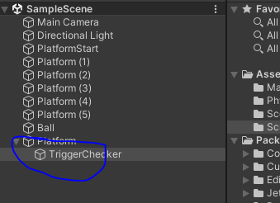
The marked one platform is the only platform to which trigger Checker is attached and also triggerChecker script is attached
This is the platform thaat we need so we disablke all other platform by selecting them and then g to the inspectr tp disable them since they all are selected they will be disabled
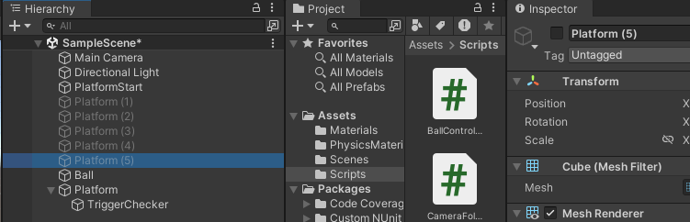
We will use them later on wwhen we want to test them but now we don't need them anymore
Now we will create a new folder naamed prefabs inside the aassets folder
we will create a prefab out of the platform since we are going to instantiate the platform again and again so we want to create a prefab so that we can reuse that create the platform in different scenerios
So drag and drop teh platorm into prefab folder
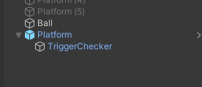
Now it is blue oin coloe the it means it is prefab
Let us understand how we can spawn the platform

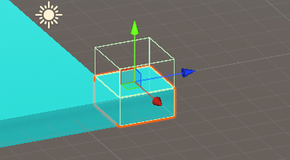
The above is teh strating position as marked above
Now when we want to spawn our platform we either want to spawn it in x direction or y direction
becayse our ball can move only in that direction
we either can make it like below
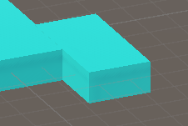
or we can create platform like below

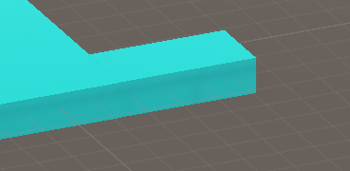
so either in x or z direction
we will spawn it when we get the direction
Now we create an empty object and name it as PlatformSpawner this empty object will help us to spawn our platform
We can make one IOA orientation match another IOA orientation by
first selecting the IOA whose orientation that we want to copy and then go to inspector

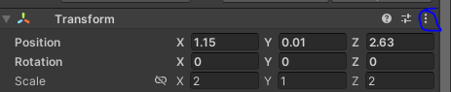
Now clicked on marked area and then in submenu click on copy and then in new submenu click on component
and then select the IOA where you want to paste the orientation and then go to inspector panel
and then click on the above marked and then click on paste and then to component
We do the same thing with Platform spawner empty object and paste platform component IOA into it
So our Platformspawner has equal position to our platoform
because we want to start spwning from the location of that platform

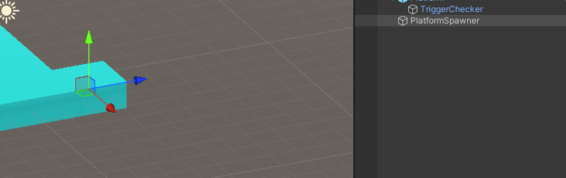
3:10

Now create a script Platform spawner attached to Platform spawner
We are goin to chek if we need ot create our new platform in x direction or in z direction
If it is in x direction then we will move the Platform spawner empty object in x direction as long as the size of platform in that Direction (whi knows) and same in z direction so

Now we have two function that is SpawnX to spawn platform in x direction and SpawnZ is to spawn platform in Z direction

Now we declare a variable named as lastpos of type Vector3 it contain the last position of the platform spqned before it was moved
We need Last position to generate new position where we want to spawn
Now we need the size of platform in a particular axis(here the platform will be generated) according to which we will move our spawngenerator and generate the plaform there
So we declare a varibale of type float named size

To acces the size of platform and to spawn we declare a Gameobject named as platform here we will store the platform IOA prefab we will do it by drag and drop prefab we made to the PlatformSpawner script component

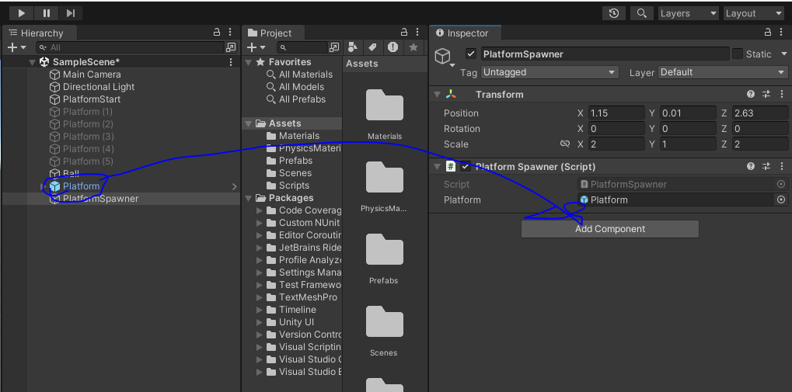

Now we will calculate the the last position as the position of the platform
It will happen inside start method
Now we get size of the platform in x direction inside start method by the cammand platform.transform.localScale.x Similarly you can do so for z and y also
Now since the size in x and z axis is equal so we need only size so that we can calculate the position of our next platform
our start method will look like this
Lets try first of all try the spawnX function because Spawnz will be almost similar to it
Now inside Spawnx functio we declare a Vector3 local varibale and will name it as pos and then we store the lastPos variable value(that is teh last position of the platform) into pos local variable
Next we need to do is since it is spawnx function so we need to spawn teh platform in x direction
Now in next line we will be incrimenting the pos.x by size variable
So we aer basically adding size to the x position So the position will be shifted to the x direction and a new platform will be created there
We create the platform by Instantiate function by this way

Instantiate(platform,pos,Quaternion.identity);

By Quaternion.identity we are not setting any rotation on the newly created platform we want tp keep it as it is in our new position
Now since the lastPos varibale has the location of the previous platform so we need to reinitialise with the value of position of new platform
so lastPos=pos;(Since pos after incrementation contains the position of the newly created platform )
So the new position is the last position of the next spawn Now below is the SpawnX function

void SpawnX()
{
Vector3 pos = lastPos;
pos.x += size;
lastPos = pos;
Instantiate(platform,pos,Quaternion.identity);
}

Now we will test it by making a loop which will run 5 times in start method

like below

void Start()
{
lastPos = platform.transform.position;
size = platform.transform.localScale.x;
for(int i = 0; i < 5; i++)
{
SpawnX();
}
}

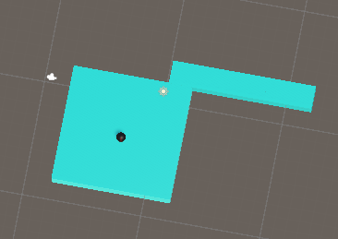
Now the platforms is produced in x direction since the spawnX will be called

Now in the saame way wwe need to create platfrom in z direction
For that we will just copy the spawnX code and paste the code in the spawnZ code
Now instead of pos.x we need to modify the pos.z since we now need to spawn in z direction
Now replace spawnX with spawnZ function in loop

Now the output will be like below

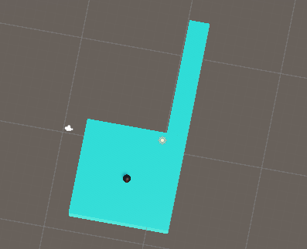
Now you can see above that All the platform are now generated in z direction

Now we need to create a mechanism so that this platform will be genrated ranomly in teh x or z direction automatically so we will do that in Next lesson

